**Page Database Creation Instructions**

1. Save the SQL script into a folder (GroupAssignment2.sql).
2. Open command prompt and run it as administrative.
3. Use cd to navigate to the folder where the SQL script is stored.
4. Type sqlplus / as sysdba.
5. Once connected, type @GroupAssignment2.sql.

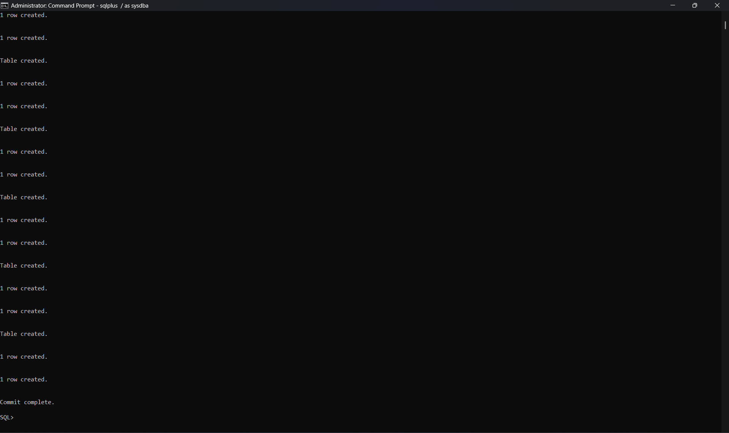

Output should look like this

1. Go to Oracle SQL Developer and connect as “GroupAssignment2_admin” with the password “GroupAssignment2Password123”. The port is 1521, and the SID is ‘orcl2355’. For the name of the database connection, name it ‘groupAssignment2Sem2’.
2. Click test. It should appear a success status at the left side of the screen.
3. The table should be there!
4. Then copy paste the script of both GroupAssignment2-sequence.sql and Trigger-Views-andOthers.sql

Output should look something like this

1. Database has been successfully created!! :D